**Deploy an application on Tomcat Manually(without automation):**

* We need to create EC2 instance on AWS.
* Connect to the ec2 instance and install git if it is not available.
* Clone the repo by using **git clone** [**https://github.com/sirishar02/project1.git**](https://github.com/sirishar02/project1.git)command.
* Go to project1 directory enter apt update and install java.
* Install the maven to build the application.
* After install the maven we can get the packages by using **mvn clean package** command.It will create the target directory.
* Exit from project1 directory Install the tomcat from apache.org.com (https://downloads.apache.org/tomcat/tomcat-9/v9.0.95/bin/apache-tomcat-9.0.95.tar.gz)
* After install the tomcat we can unzip or untar by using “**tar -zxvf apache-tomcat-9.0.95.tar.gz”** command.
* Go to **apache-tomcat-9.0.95** this directoryenter  **ll** command**.**
* We need to start the tomcat server for that go to **bin** directory (cd bin) and enter **./startup.sh** command.
* We need to give the authorization to this ec2 server to access the tomcat for that go to webapps > manager > META-INF folders and open the **context.xml** file by using text editor like vi.
* In context.xml file we can give the star(*) or any server i.p address and save the file.

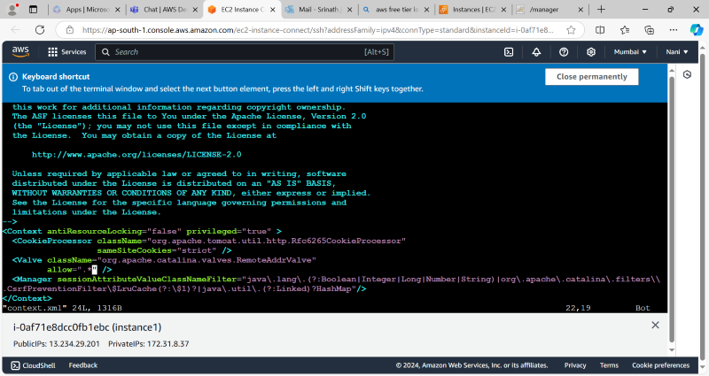

* Go to conf directory and open the tomcat-users.xml file we have to add the roles ,user name and password below like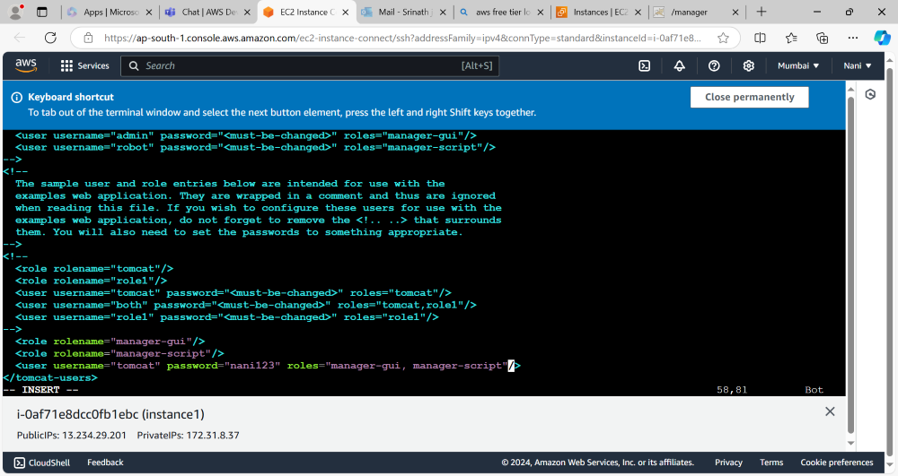
* Exit from tomcat directory and go to project1(repo) and go to target enter PWD command.
* Copy the artifact from target directory to directory where tomcat is placed.

By using **cp project1/target/myweb-8.6.2.war apache-tomcat-9.0.95/webapps** command.

* Copy the ec2 instance public i.p with port number 8080 and paste it on browser now we can access the tomcat and access the application which we have deployed on tomcat.

